
Selection Table 9: Level 7 Confidential Destruction Equipment | 1*1mm Powder
Applicable Scenarios: Classified Destruction Center, Centralized confidential destruction – v11
 | Plan 1:  YD-YTJ400BM1  YD-YTJ500BM1  YD-YTJ600BM1 | Plan 2:  YD-BM4001 | Plan 3：  YD-BM4002 | Plan 4：  YD-BM6001 | Plan 5：  YD-BM6002 | Plan 6：  YD-BM6002P | Plan 7：  YD-BM9002  YD-BM9002P
Pricing USD | 300BM1, 17,143  400BM1, 21,150  500BM1, 25,380  600BM1, 29,610 | 21,150 | 63,450 | 54,990 | 70,500 | 141,000 | 9002, 141,000  9002P, 282,000
Entry Image | 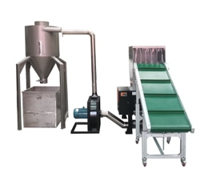 | 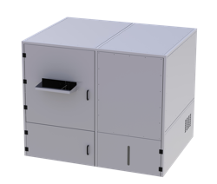 | 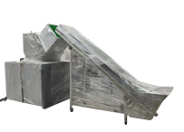 | 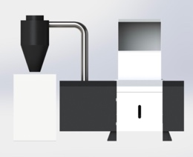 | 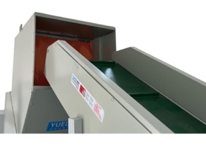 | 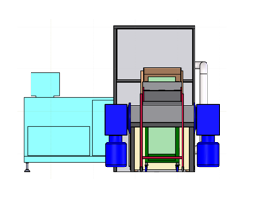 | 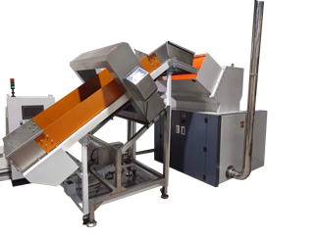
Full Machine Image | 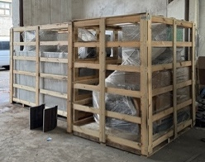 | 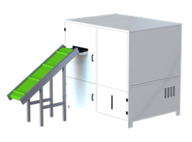 | 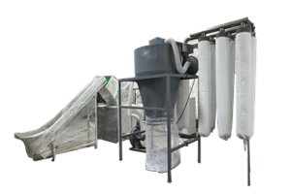 | 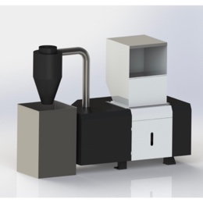 | 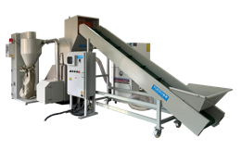 | 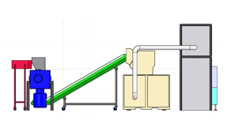 | 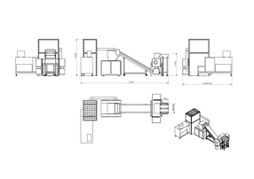
Crushing efficiency | 35 / 40 / 45KG/H  Adjustable, see footnote 1 for details | 100KG/H | 60KG/H | 50KG/H | 80KG/H | 80KG/H | 150KG/H
Shredded Size | 1*1mm  Adjustable, e.g. 2/5mm etc. | 1*1mm | 1*1mm | 1*1mm | 1*1mm | 1*1mm | 1*1mm
Sheets Shredded | 100-300 sheets | 300-500 sheets | 200-300 sheets | 300-500 sheets | 300-500 sheets | 300-500 sheets | 300-500 sheets
Entry Size | 40/ 50 / 60 CM | 60CM | 40CM | 60CM | 60CM | 60CM | 90CM
Applicable Scenarios | County-level units | Provincial and municipal units | Provincial and municipal | County-level | Provincial and municipal units | Provincial/Headquarters | Organizational Headquarters
 | https://youtu.be/q9D_uf_TdZI | https://youtu.be/RU7OpMIkUoc | https://youtube.com/shorts/KMaiAuUlj0s | https://youtu.be/i_cCRB-VJRw | https://youtu.be/v419WXU13oc | https://youtube.com/shorts/p3rOTUcy4Zg | https://youtube.com/shorts/p3rOTUcy4Zg
 | 

Attachment: Sample Display | 附件：样品展示
1mm powder - 1mm粉末状
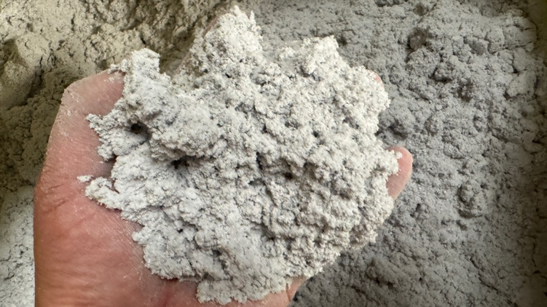 | 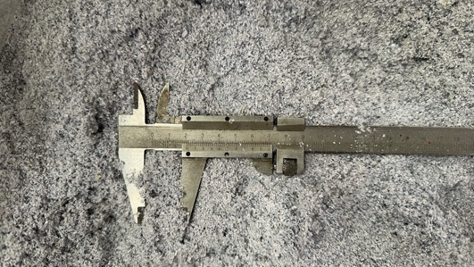 | 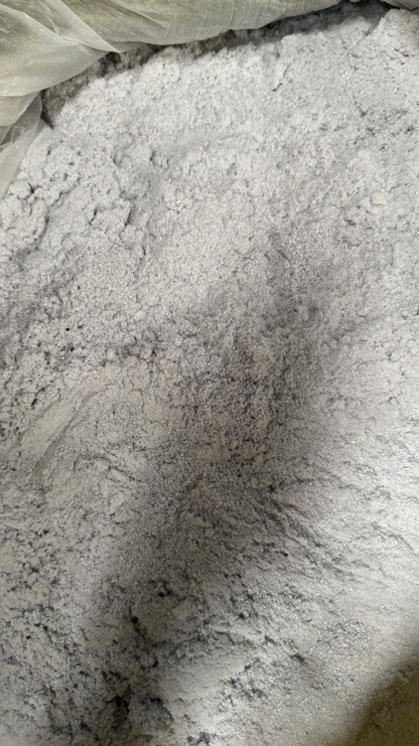
Compressed paper powder block - 纸粉压块
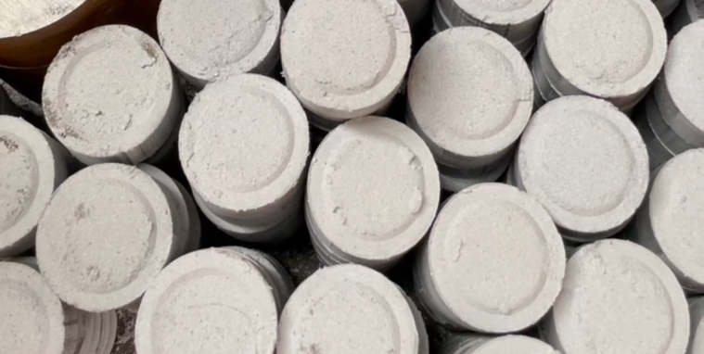 | 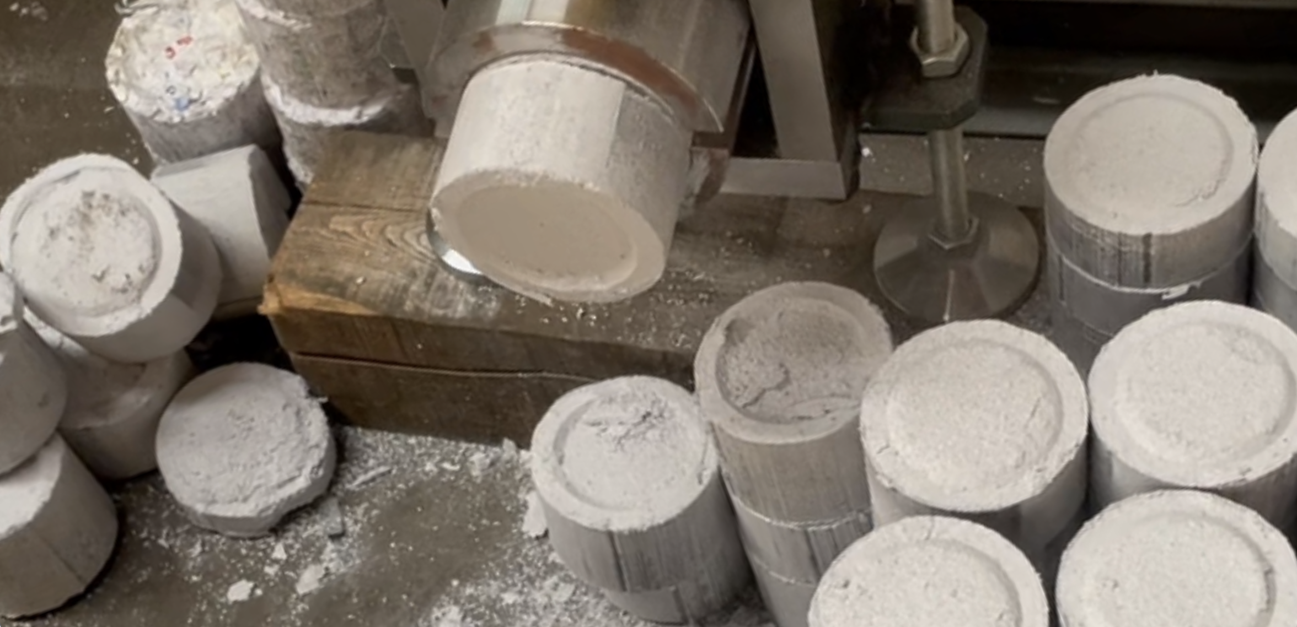 | 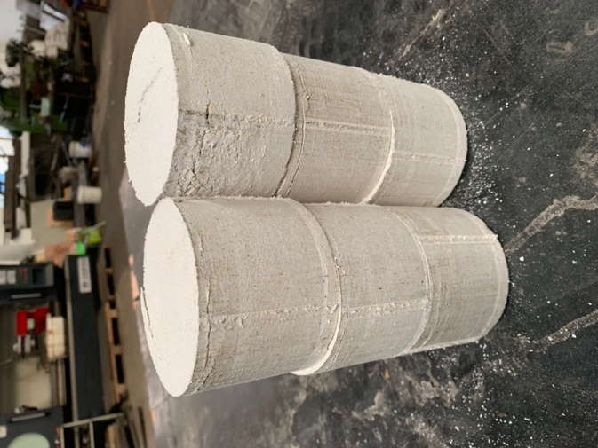
Compressed Money (RMB) block - 金钱（人民币）压块
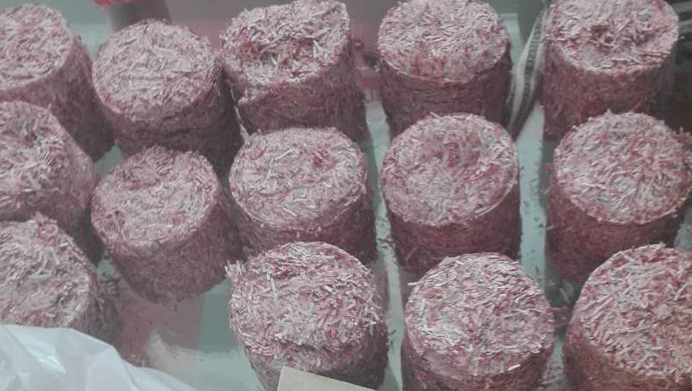 | 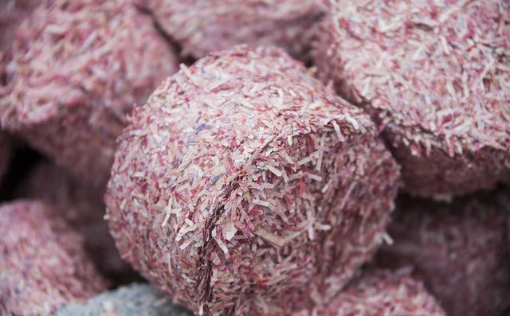 | 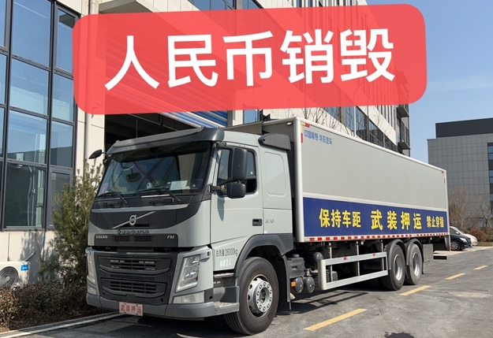

It is the output of 1mm powder; The size of the crushing can be adjusted, and the crushing efficiency is related to the size of the crushing (the larger the size of the crushing, the greater the output of the discharge). For example, the grinding efficiency of 2 mm is about twice the grinding output of 1 mm. 表格中数字为1mm粉末状的产量；粉碎的尺寸可以调整，粉碎效率 与 粉碎的尺寸有关（粉碎出来的尺寸越大，出料产量也越大）。比如：粉碎为2mm的粉碎效率，约为1mm的粉碎产量的2倍。
Adjustable, e.g. 2 / 5 / 8 / 15 mm etc. It can be customized and developed according to special use needs. 粉碎尺寸可调，例如：2/5/8/15mm等；可根据特殊的使用需求进行定制开发。

